ACME Data Integration

Overview
This document summarizes the future state of the ACME data integration and reporting process. The goal is to streamline data transfers between ACME and various third vendors while reducing manual effort and system complexity.

Current Process
Currently, widget testing data flows into the ACME Data Insights system in two primary ways:
- Automated
- Data feeds are managed end to end by We Viz, a third party visualization platform.
- Manual
  - Widget testing data is downloaded from vendor websites.
  - Data is imported into local or departmental database tables.
  - Processed data is then uploaded to ACME Insights.

Proposed Future Process
To streamline and standardize the process, the Reporting and Performance team recommends:
- Shifting widget testing file transmissions currently managed by We Viz to the ACME networking team.
- Routing all automated and manual testing files to a designated ACME network folder.
- Using a dedicated data solution server to ingest, transform, and standardize assessment data from that network folder.
- Loading the transformed testing data into the ACME Data Warehouse, where it will undergo additional cleansing and curation to support reporting and analytics.

Process Flow

- Inbound assessment data is hosted in a shared folder.
- An ETL server identifies incoming files and pushes the raw data to the ACME Data Warehouse.
- Data cleansing, validation and curation is performed in the data warehouse.
- Curated assessment data is made available for Tableau visualizations.

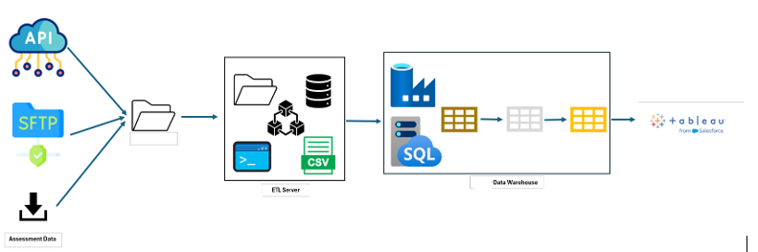
Figure 1

Data Intake (API / SFTP / Upload)
- Assessment files are delivered via API, SFTP, or manual upload to the ACME network share.
- Each file delivery is validated for timing, structure, and basic row counts.

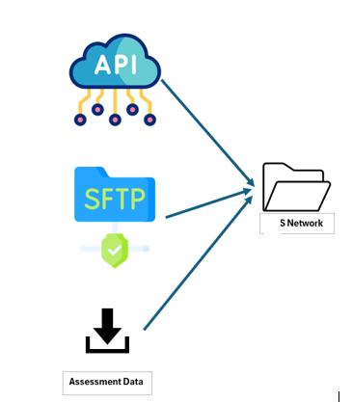
Figure 2

ETL Processing
- ETL jobs pull files from the ACME network, standardize formats, and load them into staging tables.
- File‑level metrics (rows received, loaded, rejected) are logged for every run.
- Automated notifications alert the team when a file fails ingestion or is outside expected thresholds.
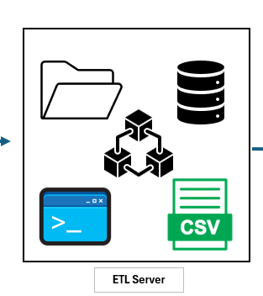

Data Cleansing & Warehouse
- Student and assessment records are validated, deduplicated, and flagged as reportable or non‑reportable.
- Curated tables in the ACME Data Warehouse are refreshed on a defined schedule.

Reporting & Dashboards
- Reportable assessment data is surfaced in Tableau dashboards for schools and district leaders.
- Dashboards display the latest successful load date/time, so users know how current the data is.
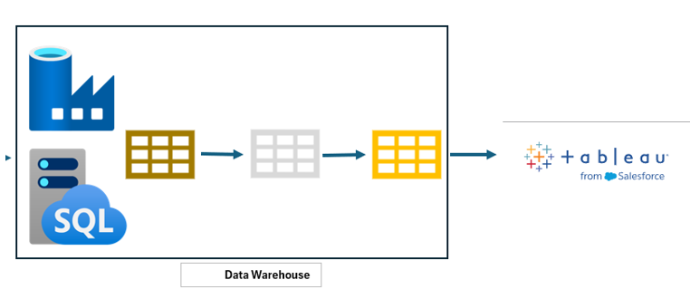

Benefits
- Reduced manual effort: Centralized automation for file transfers and loading decreases reliance on manual downloads and uploads.
- Improved data quality: Standardized ETL and cleansing rules create more consistent and accurate assessment data across vendors and feeds.
- Faster, more reliable reporting: Direct loading into the ACME Data Warehouse shortens the time from data arrival to updated dashboards.
- Stronger data governance: Ownership shifts to ACME networking and data teams, enabling better security, monitoring, and documentation of assessment feeds.
- Scalability for new vendors: A reusable integration pattern makes it easier to onboard additional assessments without redesigning the process.

